Stem Cell Therapy for Degenerative Disc Disease (DDD)

“Although not yet widespread in orthopaedics, the use of adult stem cells to address musculoskeletal conditions is an intriguing concept,” states a recent article by American Academy of Orthopaedic Surgeons. Regenerative medicine specialists, like myself, have been seeing profound results using stem cell treatments for musculoskeletal pain and feel that it is far more than an intriguing concept. It is a reality that’s already showing great promise for many patients. I’m thrilled to say that recent studies have begun to demonstrate profound improvement in degenerative disc pain similar to the results we have seen in joint disease.

Current Therapies for Degenerative Disc Disease
Current options for therapy for degenerative disc disease range from non-invasive therapeutic exercise to more invasive surgical procedures. In the following couple years, we believe we will see autologous stem cell injections become an effective, frequently employed modality that will greatly contribute to the minimally invasive treatment options.

Stem Cells Are Changing Medicine
Stem cell therapies are a fascinating addition to modern medicine and are showing enormous potential to treat a wide range of conditions. They demonstrate the ability to treat many musculoskeletal conditions, e.g. herniated discs, damaged joints and cartilage, and orthopedic conditions such as ostheonecrosis, nonunion fractures, and arthritis. Moreover, stem cells have recently begun to demonstrate success in treating challenging and often progressive systemic diseases such as multiple sclerosis, varieties of chronic obstructive pulmonary disease, Type II diabetes, Chron’s disease and a number of other autoimmune conditions.

Study of Intradiscal Stem Cell Injections
We are learning a great deal about stem cells potential thearpy for degenerative disc disease as new studies are coming to light. A recent DDD study showed dramatic improvement in pain as well as avoidance of fusion surgery. At patients 15 month follow up, 92% of study participants had avoided the surgical intervention that was recommended prior to enrollment in the study. Positive improvements were also seen in disc hydration in post-study MRIs. The following is a good example of the structural improvement. In the image on the left, the arrows point at two black, dehydrated discs – a potentially painful and much too common condition. In the image on the right, after treatment with mesynchemal stem cells, derived from the patient’s own bone marrow, noticeable improvement in disc hydration was evident.
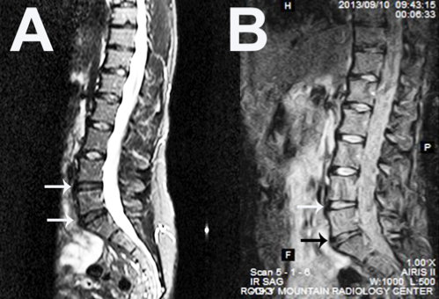

Conclusions
These initial studies are compelling and have us excited to continue advancing the techniques that will improve stem cell therapy and treatments for spinal conditions. I have spent 20 years treating spine pain and became fascinated with stem cells with the hope of non-surgically reducing debilitating back pain. I believe in the coming years there will be far more spinal procedures performed by stem cell injection than surgical intervention.

